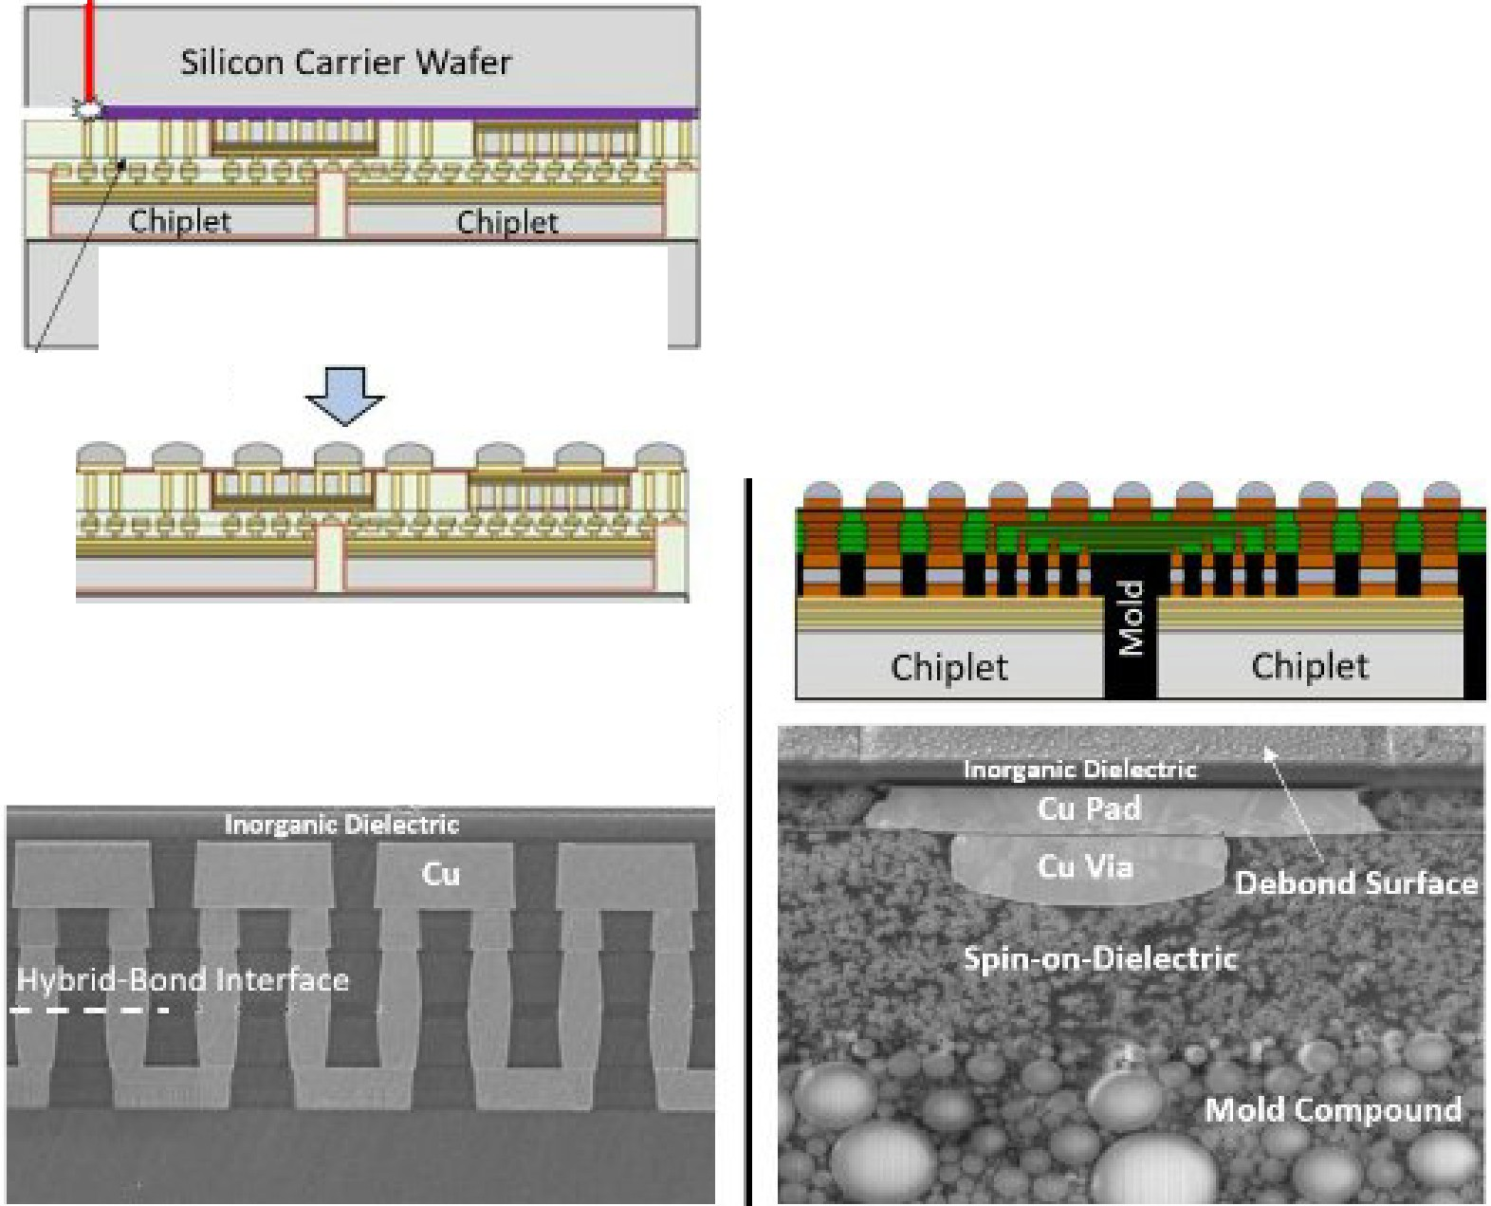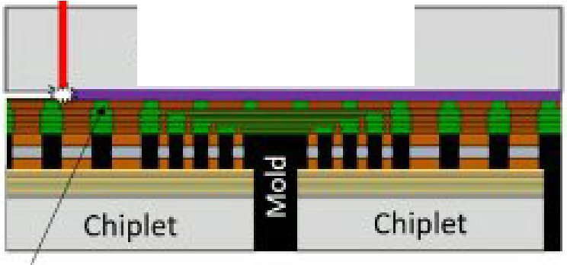
Quasi,-Monolithic Chip (QMC)
Oirganic Interposer for WLP
If!:las r
I
se
Carri r Wafer
IR Laser
se
Carrier Wafer
Silicon carrier Wafer
Support Silicon
Oxid'.e Fill/IDV/HBI
I
Org;n1ic Interpose-r
Support Silicon

Debond Surface

An Ideal Assembly Platform for 2.5D/3D Integration: Silicon carrier wafers with inorganic bond/debond layers offer sub-micron total thickness variation (TTV), excellent thermal/mechanical stability, and compatibility with high temperatures and with all silicon wafer tools and processes. As such, they can serve as an ideal assembly platform, enabling new opportunities for 2.5D/3D integration.
Intel researchers will describe an infrared (IR) laser debond technology that uses inorganic thin films to control laser release from such silicon carrier wafers. They will also discuss how they integrated it into
high-density interconnect process flows. They demonstrated transfers ofbackend (BE) metal layers, 3-µm pitch hybrid-bond interconnects (HBI), and singulated chiplets from silicon carrier wafers to silicon receiver wafers without damage to any transferred layers, chiplets, or the silicon carrier. They also demonstrated damage-free IR laser debond of an organic interposer with two redistribution layers (RDL) with up to 333 lines/mm, fabricated using Intel's Zero-Misalignment-Via (ZMV) process technology on a silicon carrier wafer. An optical model was used to predict multi-layer absorption and transmission, and to demonstrate the benefits of a shield layer.

The above images show aspects of the IR laser debond technology applied to Intel's Quasi-Monolithic Chip (QMC) and ZMV organic interposer processes.

(Paper #9.5, "IR Laser Debondfrom Silicon Carrier Wafers with Inorganic Thin Film Release Layers for High-Density 2.5D and 3D Integration," T. Sounart et al Intel)

